](https://www.liverpoolcatholic.org.uk/department/pastoral-development/jubilee)**NEWSLETTER**

**Parishes of St Anthony of Padua, Onchan; St Mary of the Isle & St Joseph, Douglas   
 Tel** 01624 675509 **Email** [saintmaryiom@rcaol.org.uk](mailto:saintmaryiom@rcaol.org.uk) **Website** [www.manxcatholic.org](http://www.manxcatholic.org)

**The Presentation of the Lord, 2nd February 2025**

**(**Year C for Sundays) (Cycle 1 for weekdays)

*(Page 449 in Missal for Order of the Mass) (Page 1005 for Mass readings)*

Dear Parishioners

I’m reading Pope Francis’s recently published autobiography entitled ‘***Hope***’. Originally intended to be published after his death he decided it should be published in his lifetime and at the start of the recently declared 2025 Holy Year. It’s an inspirational read. He expresses his gratitude to all those people, beginning with his parents and grandparents, who have influenced his journey. It’s a humbling story because Pope Francis is honest about things he has said and done of which he is ashamed; people he has offended throughout his life, even as a child growing up in Buenos Aires.

*Regina Maria Savori, my mother, was a shy little girl with large dark eyes and a seemingly natural elegance when my father saw her for the first time at the Salesian oratory of San Antonio at Almagro, in 1934. The two youngsters fell in love and when they decided to marry a year later, it was Father Enrique who celebrated the wedding on December 12th 1935 at the Basilica of Maria Auxiliadora y San Carlos Borromeo. Papa and Mama who were just 24 years old went to live at 268 Calle Varela in Flores, a small, rented single floor apartment, one of those that in Buenos Aires they call a ‘propriedad horizontal’. It was there that I was born a year later at nine pm on December 17th, their first child, Jorge Mario. They baptised me early on Christmas morning in the same church, with my maternal grandfather, Francisco, as godfather and my nona Rosa as godmother.*

*Christmas therefore has always been a double celebration for me: truly a great day to be baptised. It’s another birthday: the birthday of rebirth. It’s the day that roots us; it gives us the roots of our earthly life and our eternal life. It is the day on which we are born forever. We must remember that day because it is a flame that has been kindled and needs to be kept alight. If Christmas is also the time when we exchange gifts, for me it brought the best gift I could have received: because Baptism is a gift, it is always a free gift for everyone. Children or adults, no one has earned it; instead, it needs to be cultivated so that this seed is full of life and will take root and bear fruit. It is a gift that makes us belong to God, it gives us the joy of salvation, it tells us we are not left alone to fumble about in the darkness of history, it immerses us within his people. And it asks us to look at life as He looks at it – He who always sees in us an irrepressible kernel of beauty. The last word on the history of man is not evil, is not hatred, is not war, is not death. Baptism tells us all this. It is the first encounter with Jesus, not with a figure from the past, but with a Person living today, whom we don’t get to know in the history books, but we encounter in life. And if we, too, want to give ourselves a gift, let us begin by recalling that date, and by celebrating it as it deserves.* ***(‘Hope’, Pope Francis pp 44-45)***

*****************  
Today, 2nd February, is the **Feast of the Presentation of the Lord,** also called **Candlemas**. The story of Pope Francis being brought to church by his parents on Christmas Day to be baptised resonates with the account of Mary and Joseph bringing the child Jesus to the temple. Although Jesus was baptised years later in the river Jordan by John the Baptist, Mary and Joseph were drawn to bring the baby Jesus to the temple *‘to perform everything according to the Law of the Lord’.* Pope Francis gives a moving reflection on the significance of his own Baptism.Today’s parents may struggle to find words to describe why they want their child baptised other than a sense that it’s the right thing to do. That’s the way faith works. Their request may come to the parish office via email, but it’s the very same urge that inspires parents of a newly born child to seek baptism for their children. *Fr John*

*I will do what I so often did with my fettered hands and what I will gladly do again and again as long as I have a breath left: I will give my blessing. I will bless this land and the people; I will bless the Church and pray that the fountains may flow again fresher and more freely; I will bless all those who have believed in me and trusted me, all those that I have wronged and all those who have been good to me – often too good…..May God shield you all. I ask for your prayers. And I will do my best to catch up, on the other side, with all that I have left undone here on earth. Towards noon I will celebrate Mass (in my cell) once more, and then in God’s name, take the road under his providence and guidance*.  **Fr** **Alfred Delp SJ** **(Executed in Nazi Germany, 2nd February 1945)**

* **First Holy Communion preparation for children with special educational needs**: A few parents have been in touch with us whose children missed out on making their First Holy Communion because of their additional educational needs. Some of these children are now in secondary school. We will shortly begin preparation for these children. Please contact the parish office by email this week if you have a child who would be eligible.
* We regularly receive enquiries from adults (over 18) who wish to become Catholics or from those who, although Baptised in the Catholic church, have never been Confirmed or made their First Holy Communion. This week we will be reconvening our **‘Come and See’** group which meets to explore our Catholic faith.
* **The Warm and Cosy Hub** is open in the meeting room at the back of St Mary’s Church **every Monday and Friday** from **10am to 2pm** until further notice. Thanks to the volunteers who help with this.
* **The T and Chat group** will meet on **Tuesday 4 February 2025** from **10.30am to 12 noon** at St Anthony’s Pastoral Centre. Refreshments and cake will be served. Everyone warmly welcomed. Please contact Josie on 406063.
* **Island Spirituality Network** meeting will take place on **Saturday 8 February 2025** from **10am to 1pm** at St John’s Mill. The guest speaker will be **Rt Revd Tricia Hillas, Bishop of Sodor and Man**. Her theme for the morning will be “*Setting Sail, A Voyage of Faith*” when she will speak about her journey with God. Everyone welcome.

**Masses and Services for the coming week**

*All Masses and Services from St Mary’s are live-streamed*

|  |  |  |  |
| --- | --- | --- | --- |
| **Saturday 1st February**  *St Brigid, Patron of Ireland*  **The Presentation of the Lord** | 5.00pm | St Mary’s | Shirley Savage, anniversary |
| **Sunday 2nd February**  **The Presentation of the Lord** | 9.30am  11.00am | St Anthony’s  St Mary’s | People of our Parishes  Ben McCarrick, recently died |
| **Monday 3rd February**  St Blaise, St Ansgar | 12.10pm | St Mary’s | Deceased Clergy |
| **Tuesday 4th February** | *10.00am*  12.10pm | *St Anthony’s*  St Mary’s | *Eucharistic Service*  Mary & Matthias Kaddu, deceased |
| **Wednesday 5th February**  St Agatha | 12.10pm | St Mary’s | Mr Joseph, anniversary |
| **Thursday 6th February**  St Paul Miki & Companions | 10.00am  12.10pm | St Anthony’s  St Mary’s | Dawson, Kassapian & Wild families  David Keane, anniversary |
| **Friday 7th February** | 12.10pm | St Mary’s | Violet Corlett, recently died |
| **Saturday 8th February**  5th Sunday in Ordinary Time | *No Confessions*  5.00pm |  | *No Exposition or Confessions today*  People of our Parishes |
| **Sunday 9th February**  5th Sunday in Ordinary Time | 9.30am  11.00am | St Anthony’s  St Mary’s | Patcy Rice, recently died  Brian Leneghan, recently died |

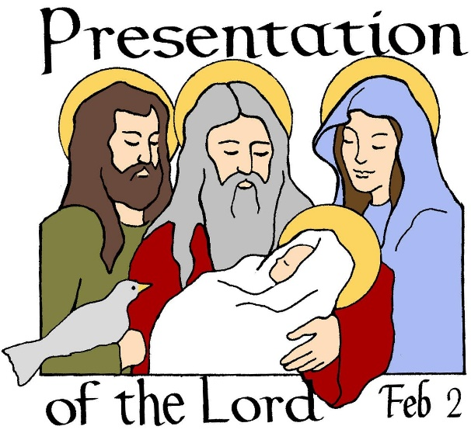They came, as called, according to the Law.

Though they were poor and had to keep things simple,

They moved in grace, in quietness, in awe,

For God was coming with them to His temple.

Amidst the outer court’s commercial bustle

They’d waited hours, enduring shouts and shoves,

Buyers and sellers, sensing one more hustle,

Had made a killing on the two young doves.

They come at last with us to Candlemas

And keep the day the prophecies came true

We glimpse with them, amidst our busyness,

The peace that Simeon and Anna knew.

For Candlemas still keeps His kindled light,

Against the dark our Saviour’s face is bright.

*(Malcolm Guite)*